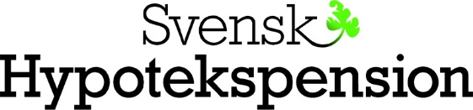

Svensk Hypotekspension Fond 3 AB (publ)

Press Release 12 September 2019

Svensk Hypotekspension AB examines refinancing options with respect to Svensk Hypotekspension Fond 3 AB
Svensk Hypotekspension AB has mandated Barclays Bank Plc and DNB Bank ASA, Sweden Branch as Joint Arrangers, to explore refinancing options with respect to Svensk Hypotekspension Fond 3 AB (SHPF 3). The mortgage backed fixed rate notes issued by SHPF 3 on 9 February 2016 (the Notes) will become eligible for optional redemption from 27 January 2020, in accordance with the terms and conditions of the Notes.

Svensk Hypotekspension Fond 3 AB (publ)

