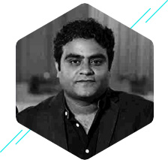Asad Khan, is a serial entrepreneur who comes with an extensive experience of 13 years in the software testing landscape. He has always been passionate about his work and has bootstrapped all his businesses.
Asad Khan
Co-founder & CEO, LambdaTest

In 2017, he co-founded LambdaTest, a cloud-based testing platform popular among web developers, digital marketing companies, web agencies in the European and North American market. Within a short span of one year since being founded, under Asad’s dynamic leadership, the company has reached 132 countries.
Prior to this, Asad founded multimillion dollars pure play independent testing services company called 360logica for ISVs. It was acquired by Saksoft Inc. in 2014.

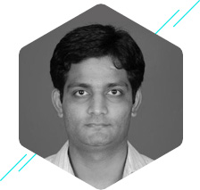Harish comes with an experience of 14 years and has managed large distributed systems at interglobe and Moireis.
Harish Sharma
Co-founder | head – Technology

Prior to which he co-founded and was the head of technology at e-care Technology Labs Pvt. Ltd. He was also a key contributor at travelport.

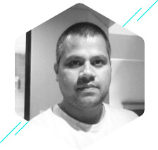 Jay Singh is a technology sales professional with 14 years of experience in leading sales teams in startups and rapidly growing establishing technology companies.
Jay Singh
Co-founder |head - Sales and Marketing

He has been working with companies like Symphony and LeadSquared and also co-founded sales consulting company Business Mojos.

Shayan is a serial entrepreneur who has managed 100s of customer relationship. He also co-founded Net Funda Technologies.
Shayan
Co-founder |head of Customer Success

