FOR IMMEDIATE RELEASE
Contact: Jess Myers
651.290.7465
jessm@ewald.com

ARCS Foundation: Scott Fouse Joins SEAC
Space science leader added to advisory council, engaging external decision-makers with ARCS

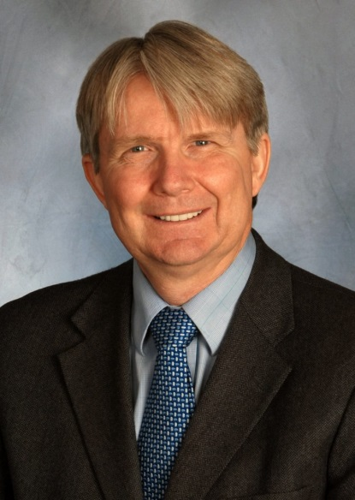
ST. PAUL, Minn., February 28, 2018 – Members of ARCS Foundation welcome Scott Fouse as the newest member of its Science and Engineering Advisory Council (SEAC). Mr. Fouse has recently announced his retirement from the Lockheed Martin Advanced Technology Center in Palo Alto, CA, where he was Vice President of the Advanced Technology Center (ATC). Mr. Fouse’s recognition as a leader managing highly-complex technical portfolios, and his dedication to advancing STEM education will add significant insights to the SEAC discussions.

SEAC was established in 2009 and is composed of distinguished scientists, engineers and scholars from across the country, drawing on their collective experience in government, industry, and academia. The council provides advice and recommendations to the ARCS Foundation National Board on the future of science and science education and identifying strategies for engaging external decision-makers with ARCS Foundation.

“I am immensely honored to join this distinguished group of individuals who are dedicated to supporting the mission of ARCS and STEM education in the US,” said Mr. Fouse. “I attended my first SEAC meeting in January and came away very enthused with the discussions and impressed with the collaboration between SEAC and the ARCS Foundation National Board.”

Mr. Fouse has broad experience in science and technology. He is an Associate Fellow of the American Institute for Aeronautics and Astronautics (AIAA) and a Full Member of the International Academy of Astronautics (IAA). Mr. Fouse serves on Boards or Executive Committees of Rocket Lab, the Georgia Tech Research Institute, COSPAR, Aerospace Historical Society, American Geophysical Union, and is a Board Trustee of the IAA.

“I am pleased to have Scott join SEAC,” said Andi Purple, ARCS Foundation president. “His experience in both the industrial and entrepreneurial arenas, as well as his interest in STEM education, will add greatly to the council.”

Mr. Fouse has a BS in Physics from the University of Central Florida, and a MS in Electrical Engineering from the University of Southern California. He and his wife, Melody, make their home in Scottsdale, AZ.

For more information, visit the ARCS Foundation conference webpage.

# # #

About ARCS® Foundation: ARCS Foundation is a national nonprofit volunteer women’s organization that promotes American competitiveness by supporting talented U.S. citizens working to complete degrees in science, technology, engineering, mathematics (STEM) and health disciplines at 50 of the nation’s leading research universities. Since 1958, the organization has awarded more than $100 million to more than 10,000 students. ARCS Foundation Scholars have produced thousands of research publications and patents, secured billions in grant funding, started science related companies, and played a significant role in teaching and mentoring young people in the STEM pipeline. More information is available by visiting www.arcsfoundation.org.

