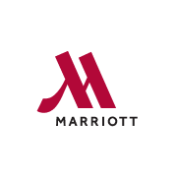
CONTACT: Oakland Marriott City Center
1001 Broadway, Oakland, California 94607 USA
+1 510-451-4000
http://www.marriott.com/hotels/travel/oakdt-oakland-marriott-city-center/

Oakland Marriott Bellman Goes Beyond the Call of Duty
Marriott veteran Tony Scott honored at Annual Hotel Hero Awards Ceremony

Oakland, California – May 2nd, 2018 – Heroes come in many forms, and some shine their light on the world through a generosity of spirit and devotion that trickles down to all those who meet them. One such hero has been serving guests for more than 34 years at Oakland Marriott City Center. Tony Scott, veteran bellman at the hotel, was recently honored at the Annual Hotel Hero Awards, receiving the award for going Beyond the Call of Duty in the name of hospitality.

The Hotel Hero Awards celebrate and recognize the industry’s most exceptional members and hotels, presenting awards to individuals who define exceptional hospitality with their dedication to their hotels and guests. Held on April 18th, the event handed out awards to the industry’s many esteemed and unsung heroes, including Oakland Marriott’s own Mr. Scott.

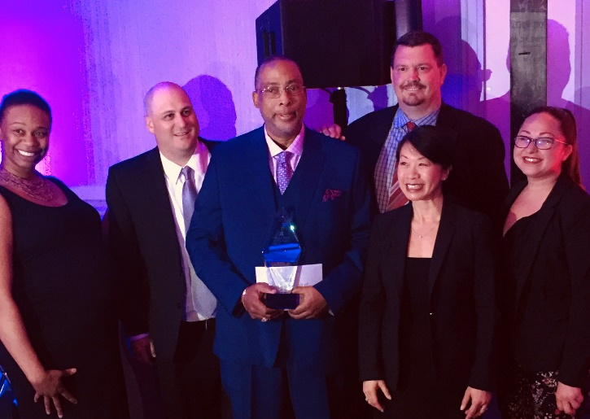
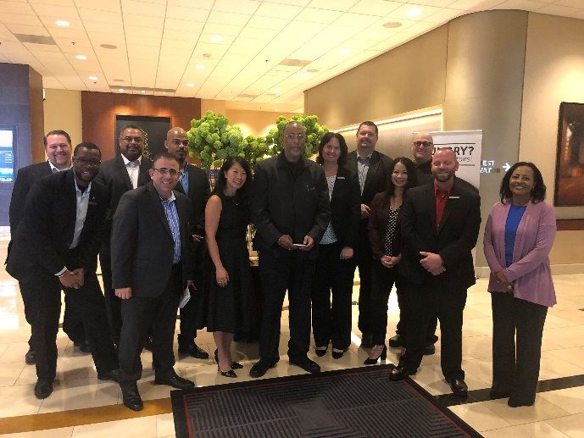
Tony Scott receives award for going Beyond the Call of Duty
Tony Scott, with his fellow Marriott associates
Commuting two hours from Sacramento to Oakland, Tony arrives at the hotel daily with a smile, ready to greet guests and provide them with a warm experience. He is often asked for by name by many guests, and he passes that same generosity and care on to his fellow associates.

A man of great faith, Tony was a minister for his church and mentors a group of young men who, to this day, text him for inspiration. The property often receives letters of accolade about Tony, or personal stories about the great care he took to make guests feel at ease.

Tony is always humbled when recognized by the guests for his care and attention, but one of his greatest rewards was the artwork he received from an adorable pair of four and six-year-old siblings who thanked him for showing them such a great time while they were in Oakland, CA.

The team at Oakland Marriott City Center is proud to have genuine heroes, like Tony, as part of the family, and we look forward to many more years with him leading the way in hospitality. His warm smile, genuine personality and positive outlook serve as daily inspirations to everyone.

About Oakland Marriott City Center

Oakland Marriott City Center, a modern hotel that mirrors its dynamic downtown surroundings, brings guests close to an inspiring local food movement, top sports teams, a thriving arts culture and more. The hotel’s refined guest rooms ooze urban cool, boasting perks like cutting-edge technology and spa-quality rain showers. Iron & Oak, our signature bar and restaurant, offers new American cuisine prepared from locally-sourced ingredients. The hotel offers a fitness center, outdoor pool and makes it easy to set out exploring nearby attractions like Oracle Arena and Jack London Square. The hotel also offers guests a fantastic vantage point to discover Silicon Valley and Northern California wineries – located just moments from the property.

# # #

