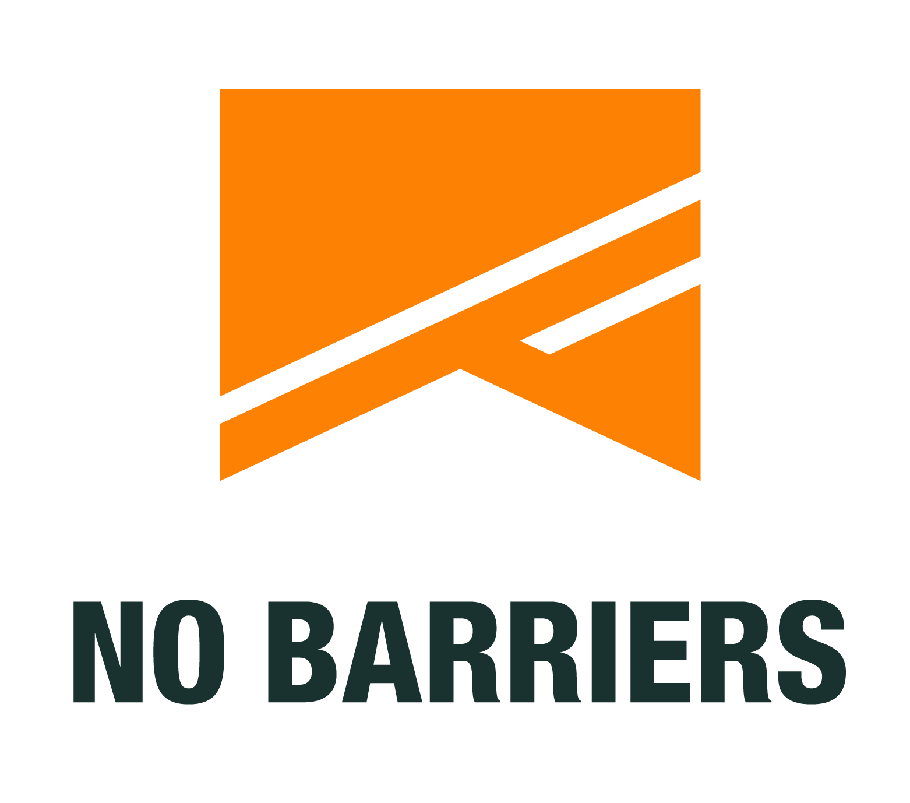

No Barriers selects 2019 Raytheon Veteran Wilderness Expedition Team

Disabled veterans to trek Big Bend National Park and Rio Grande

FORT COLLINS, CO (Sept. 26, 2019) — Raytheon Company (NSYE: RTN) and the non-profit No Barriers USA today announced the 2019 Big Bend Veteran Wilderness Expedition team. Disabled veterans from Alabama, Arizona, New Mexico, Oklahoma and Texas will participate in the Raytheon-funded expedition Oct. 5-13 at Big Bend National Park and the Rio Grande River in Southwest Texas.

The expedition is designed to push participants physically and mentally, while providing a foundation for stretching goals, facing adversity and leading others.

“For the returning men and women of our armed forces who face physical, mental or emotional injuries, the transition back to civilian life frequently presents unique and significant challenges,” said Jon Kasle, vice president of Communications for Raytheon Missile Systems. “Through a process of individual introspection, teamwork and camaraderie, No Barriers expeditions help impacted veterans reclaim a more complete sense of purpose and gain confidence to improve their quality of life.”

By combining comprehensive curriculum with physically challenging activities such as long-distance hiking and rafting, disabled veterans gain new strategies and skills that help them confront and overcome barriers. Participants take part in online coursework before and after the expedition to internalize the “No Barriers Life” and receive continual support throughout all phases of the expedition.

The 2019 Big Bend Veteran Wilderness Expedition team includes:
- Alexandria “Zayna” Aranda – Albuquerque, New Mexico, U.S. Army.
- Charles Causbie – Tucson, Arizona, U.S. Army.
- Leonard Day – Window Rock, Arizona, U.S. Army.
- Margaret “Margo” Gonzales – Guthrie, Oklahoma, U.S. Air Force.
- William “Bill” Gwaltney – White Rock, New Mexico, U.S. Marine Corps.
- Steven Lumbley – Conroe, Texas, U.S. Army.
- Jose Machado – Lancaster, Texas, U.S. Army.
- Hector Rodriguez – San Antonio, Texas, U.S. Marine Corps.
- Pedro San Miguel – Enterprise, Alabama, U.S. Army.
- Alumnus Coach - Jeremy Spruce, U.S. Army, Oro Valley, Arizona.

This is the sixth year Raytheon and No Barriers have partnered for a veteran wilderness expedition. Previous journeys took teams to the Grand Canyon in Arizona, Rocky Mountains in Colorado and the Wind River Range in Wyoming.

About No Barriers USA
No Barriers improves the lives of veterans with disabilities through curriculum-based experiences in challenging environments. Our experiences serve as both an opportunity for growth and a catalyst for change as these brave men and women stretch physical and emotional boundaries, foster camaraderie, pioneer through adversity, and step up and serve others. Through experiences that are one part adventure, one part curriculum and one part physical challenge, we show veterans that what’s within them is stronger than what is in front of them. The mission of No Barriers USA is to unleash the potential of the human spirit. Through transformative experiences, tools and inspiration, No Barriers helps people embark on a quest to overcome obstacles, live a full life and contribute their absolute best to the world. Follow us on Facebook and Twitter.

About Raytheon
Raytheon Company, with 2018 sales of $27 billion and 67,000 employees, is a technology and innovation leader specializing in defense, civil government and cybersecurity solutions. With a history of innovation spanning 97 years, Raytheon provides state-of-the-art electronics, mission systems integration, C5I® products and services, sensing, effects and mission support for customers in more than 80 countries. Raytheon is headquartered in Waltham, Massachusetts. Follow us on Twitter.

Contact:
Summer Clowers
No Barriers Project Coordinator
summer.clowers@nobarriersusa.org
970-484-3633

John Toth
No Barriers Warriors Director
john.toth@nobarriersusa.org
970-484-3633 x 312

Raytheon
John B. Patterson
+1.520.440.2194
rmspr@raytheon.com

