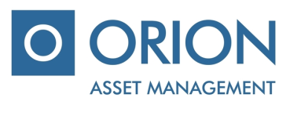

UAB “Orion Asset management”

Private limited company, registered office A. Tumėno g. 4, B corps, 7 floor, Vilnius, mob.: + 370 5 231 3833, faks.: +370 5 231 3840, email.: oam@orion.lt (hereinafter “Management Company”), which controls and manages the Company.

IKKB “OMX Baltic Benchmark Fund” (hereinafter – “the Company”), voting ballot of the shareholders additional extraordinary meeting, which will take place on 12 December 2016

Shareholders name, surname ………………..…………………....................…….....................................................................…

Shareholders identification number………………………………………....................................................................................

Number of shares……….....................................................................................................................................................................

Agenda of the meeting | - Approval of the Company`s amendments of articles of association due to new currency changeover process, i.e. EUR implementation and appointment of the Company representative due to new version of articles of association.

VOTE

ISSUES OF THE AGENDA | DECISION | Include „for“ / „against“
- Approval of the Company`s amendments of articles of association and appointment of the Company representative | To approve Company`s amendments of articles of association due to new currency changeover process, i.e. EUR implementation and to appoint Management Company director Ramunas Baranauskas to sign new version of the Company`s articles of association.

Attachments:
- New version of Company`s articles of association.

________________________________________________
(Shareholders (representative) name, surname, signature)

