Nasdaq OMX Nikolaj Plads 6 P.O. Box 1040 1007 København K

12th of August 2015
Interim report
After a slow sale during spring, rising raw material prices, loss of a big contract and a general weaker demand during the latest months, we must note a lower turnover compared to last year’s figures.
Among others the big decrease in the number of housebuilding projects, a loss of a big contract and the missing turnover from the winter storms in the previous year has set its marks on the turnover in the building & construction sector. The lost contract has only begun to show its full effect during 3rd Quarter. The strong increasing raw material prices, which we have not been able to adjust in existing running one year contracts, had and will have an effect on the profit on short term.
The sales of the products to industrial companies has developed better in the 3rd quarter, but is despite of that cumulated on a lower level than in 2013/14. Although this has not materialized at the previous expected level. The investments and organizational developments in the processing department has so far not given the expected growth, but the continuing focus on developing this area further is kept as a high priority.
The cautious attitude in several sectors, which was based on the uncertainty prior to the election to the Danish Parliament, a weaker export development as well as the credit crisis in Greece, are as well some of the reasons for a lower development as expected.
The capacity costs are on level with last year. We have despite of the above mentioned development kept a high level of investments in our strategically announced sales areas to secure a future growth in these areas. Parallel to this we have started activities to adjust the capacity and the cost to an adequate lower level.
RIAS A/S estimates, based on the above mentioned weaker development, the loss of the contract and the maintained high level of investments on strategic areas a result in the level of DKK 5 – 6 million DKK before tax against a previous expected level of DKK 8 – 11 million DKK before tax.
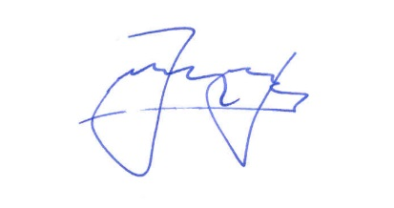
Yours faithfully RIAS A/S
Henning Hess

