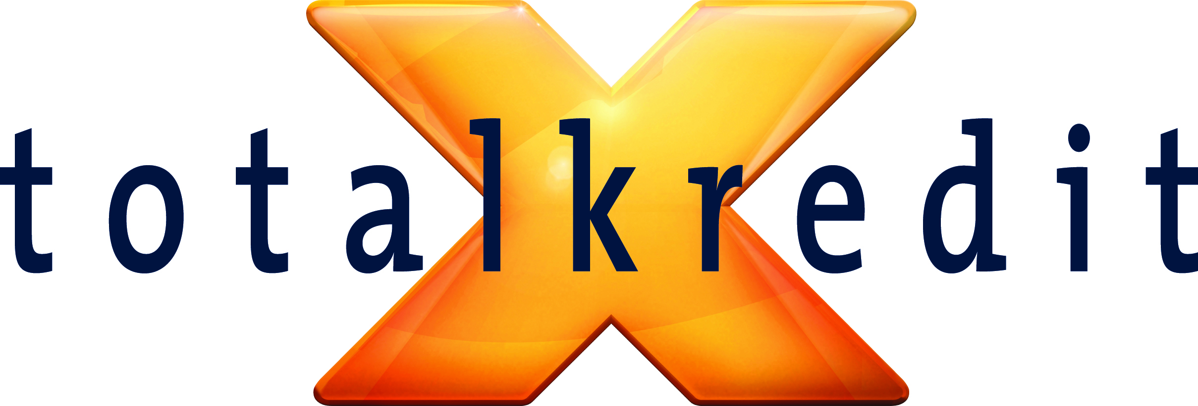
To the NASDAQ OMX Copenhagen A/S

Debtor distribution data
23 September 2014

Pursuant to s 27a(1) of the Danish Securities Trading Act, Totalkredit A/S hereby publishes debtor distribution data for callable mortgage bond series as at
19 September 2014 in the attached file.

Furthermore, the data will be distributed in the usual way through NASDAQ OMX Copenhagen A/S. Data on Nykredit and Totalkredit bonds is also available by ISIN code in Excel format on nykredit.com/ir.

For further information about data format and contents, please refer to the NASDAQ OMX website.

Questions may be addressed to Trine Ahrenkiel, Head of Corporate Communications, tel +45 44 55 14 70, or Kim Brodersen, Investor Relations Manager,
tel +45 44 55 24 21.

Yours sincerely

Totalkredit A/S

