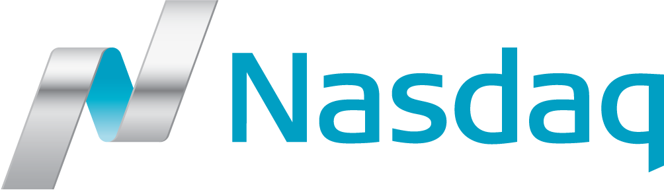
2017-04-12
IT – Connectivity – Nasdaq Nordic and Nasdaq Baltic will introduce a new INET MiFID II Test Environment – Connectivity Information (1/17)
Nasdaq Nordic and Nasdaq Baltic will introduce a new INET test environment, INET Test (M2), to facilitate testing of MiFID II functionality prior to MiFID II comes into force. The new test environment will be available from April 24, 2017. See IT-Notice 23/17.
Connectivity information
A new subnet, 159.79.70.0/23, for access to the new INET Test (M2) environment is now available at Nasdaq Nordic Primary Site VASBY. ITCH and NLS UDP multicast services will use the existing INET and Genium INET Test A source subnet 159.79.85.80/28.
Documentation
Please see new and updated documents which are available at Nasdaq Nordic Technical Information, under “Connectivity” and under “INET Nordic, Connectivity & Access, Connectivity Guidelines”.
- Nasdaq Nordic “Announced IP nets” to providers
- “Connectivity Guideline INET MiFID II (M2) Test – IP addresses and port numbers”
- Nasdaq Nordic “Bandwidth recommendations”
How to order INET Test (M2) multicast services
Connectivity providers and customers who want access to the new INET Test (M2) ITCH and NLS Multicast services must contact Nasdaq Global Information Services (GIS), dataproducts@nasdaq.com.
The new subnet, 159.79.70.0/23, is announced to Nasdaq connectivity providers, customers utilizing Nasdaq NODE services and Nasdaq Co-location customers.
Technical prices
Technical access fees for INET Test (M2) are initially complimentary. From July 1, 2017, prices are according to the INET Test (NTF) technical fees in the Nasdaq Nordic Technical Services Pricelist.

Questions and feedback
For further information and feedback concerning this information, please contact:
Ronny Thellman
Tel: +46 8 405 6313
E-mail: ronny.thellman@nasdaq.com
or technicalrelations@nasdaq.com

For any commercial questions please contact:
Richard Gaudy
Head of Sales Europe
Global Trade Management Services
Global Connectivity Services
Tel: +46 8 405 6103
richard.gaudy@nasdaq.com

Support
For technical questions, please contact Nasdaq Cash Equity Operations:
Tel: +46 8 405 6410
E-mail: operator@nasdaq.com
or
Technical Support – Co-location & NODE services:
Tel: +46 8 405 6980
E-mail: TechOpsEU@nasdaq.com
Best regards,
Nasdaq Nordic and Nasdaq Baltic
Nasdaq Copenhagen, Nasdaq Helsinki, Nasdaq Iceland, Nasdaq Riga, Nasdaq Stockholm, Nasdaq Tallinn and Nasdaq Vilnius are respectively brand names for Nasdaq Copenhagen A/S, Nasdaq Helsinki Ltd, Nasdaq Iceland hf., Nasdaq Riga AS, Nasdaq Stockholm AB, Nasdaq Tallinn AS and AB Nasdaq Vilnius. Nasdaq Nordic represents the common offering by Nasdaq Copenhagen, Nasdaq Helsinki, Nasdaq Iceland and Nasdaq Stockholm. Nasdaq Baltic represents the common offering by Nasdaq Tallinn, Nasdaq Riga and Nasdaq Vilnius.

During the period April 24th until June 30th Nasdaq will charge for one INET test system regardless.

