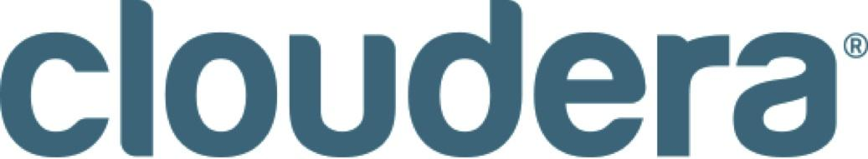

Cloudera Recognized in Two Categories by 2014 DBTA Readers’ Choice Awards

Named Best Analytical Platform (Overall) and Best Hadoop Solution by
Database Trends and Applications Readers

PALO ALTO, Calif., August 6, 2014 – Cloudera, the leader in enterprise analytic data management powered by Apache Hadoop™, today announced it has been named Best Analytical Platform (Overall) and Best Hadoop Solution by Database Trends and Applications magazine 2014 Readers’ Choice Awards. Nominees and winners were selected by Database Trends and Applications’ readers, who cast more than 22,000 votes across 21 categories.

This recognition by the IT community for Cloudera underscores the dramatic changes taking shape across the globe as we usher in a new era of data analytics - fueled by the dramatic rise in unstructured data from mobile devices, sensors and machines that have propelled the Internet of Things (IoT). By 2020, IDC predicts the digital universe will amount to over 5,200GB per person worldwide. Cloudera’s data management Hadoop-based platform drastically changes the way in which customers can make business decisions grounded in data insights.

“DBTA readers face the complicated task of managing and manipulating data to extract meaningful insights. That’s the business challenge we strive to address at Cloudera,” said Amr Awadallah, chief technology officer, Cloudera. “At Cloudera we make decisions each day that are targeted at expanding on our existing platform to meet users’ needs. We are pleased that DBTA readers find our Hadoop solution and analytical platform to be the best on the market.”

With a foundation of open source innovation, Cloudera is the only Hadoop distribution that enables organizations to build an enterprise data hub, one place to store, process and analyze all data, in any format, for any amount of time–complementing customers’ existing data management systems. Additionally, Cloudera offers the only compliance-ready Hadoop distribution with security and encryption built in at the core, zero downtime administration through Cloudera Manager, and a dedicated customer support team to ensure customers’ success.

About Cloudera
Cloudera is revolutionizing enterprise data management by offering the first unified Platform for Big Data, an enterprise data hub built on Apache Hadoop™. Cloudera offers enterprises one place to store, process and analyze all their data, empowering them to extend the value of existing investments while enabling fundamental new ways to derive value from their data. Only Cloudera offers everything needed on a journey to an enterprise data hub, including software for business critical data challenges such as storage, access, management, analysis, security and search. As the leading educator of Hadoop professionals, Cloudera has trained over 22,000 individuals worldwide. Over 1,000 partners and a seasoned professional services team help deliver greater time to value. Finally, only Cloudera provides proactive and predictive support to run an enterprise data hub with confidence. Leading organizations in every industry plus top public sector organizations globally run Cloudera in production.

www.cloudera.com

Connect with Cloudera
Read our blog: http://www.cloudera.com/blog/
Follow us on Twitter: http://twitter.com/cloudera
Join the Cloudera Community http://cloudera.com/community
Visit us on Facebook: http://www.facebook.com/cloudera

###

Cloudera, Cloudera Platform for Big Data, Cloudera Enterprise Basic Edition, Cloudera Enterprise Flex Edition, Cloudera Enterprise Data Hub Edition and CDH are trademarks or registered trademarks of Cloudera in the United States and in jurisdictions throughout the world. All other company and product names may be trade names or trademarks of their respective owners.

