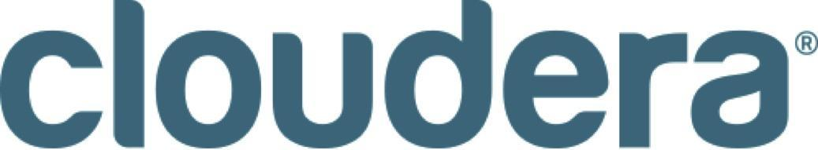

Cloudera Acquires DataPad Technology Assets and Team to Strengthen Enterprise Data Hub Offering

Acquisition Brings Together Some of the Best Data Engineering Technology and Talent in the Industry; DataPad CEO, Co-founder and Python Expert Wes McKinney to Lead Backend Systems Initiatives

PALO ALTO, Calif., September 30, 2014 – Cloudera, the leader in enterprise analytic data management powered by Apache Hadoop™, today announced that it has acquired the technology assets of DataPad, an innovator in the exploration and analysis of big data sets. The acquisition will further strengthen Cloudera’s enterprise data hub offering by simplifying data processing and analysis on Big Data. DataPad’s Python-based framework will accelerate adoption of Cloudera’s leading Big Data management and analytics platform and the team’s expertise further expands the breadth of open source committers and contributions from Cloudera. Terms of the deal were not disclosed.

DataPad co-founders, Wes McKinney and Chang She, well-known open source contributors and system architects, and the DataPad team, will join Cloudera. McKinney is the creator of the open source project Pandas, the Python open source library and is also the author of the best-selling Python for Data Analysis. She, a long-time colleague of McKinney, is also a core developer of Pandas. They will lead the company’s efforts to build high-performance data backends for business intelligence and analytic use cases, simplifying use of Cloudera’s products.

As a part of Cloudera, the DataPad technology and team will drive the Cloudera Enterprise big data platform to be more accessible to developers, data scientists, and the company’s ecosystem of partners.

“We are thrilled to have the DataPad team join Cloudera and look forward to their contributions to the Cloudera roadmap,” said Peter Cooper-Ellis, vice president, Engineering, Cloudera. “We’ve long been supporters of the DataPad team and have been impressed with their engineering work. Together, we possess some of the best talent in the data engineering sphere. The deep Python expertise that DataPad brings to Cloudera will further accelerate our data engineering capability.”

Python is arguably the most important programing language for today’s software developers to gain fluency and has tens of thousands of users. This open source language can be used on any operating system and easily processes text, numbers, images, scientific data and more. Many of today’s largest industries depend on Python in their daily operations. Big Data application developers find the language powerful and easy to use.

“Since the early days of DataPad, we’ve collaborated closely with the Cloudera team on engineering challenges for analytics systems,” said McKinney. “Working side by side with some of the best and brightest open source and data engineering talent in the industry can only benefit and improve additional innovation. Bringing our Python expertise to the Cloudera team will allow Cloudera to deliver better developer and data analysis capabilities.”

About Cloudera
Cloudera is revolutionizing enterprise data management by offering the first unified platform for Big Data, an enterprise data hub built on Apache Hadoop. Cloudera offers enterprises one place to store, access, process, secure, and analyze all their data, empowering them to extend the value of existing investments while enabling fundamental new ways to derive value from their data. Cloudera’s open source Big Data platform is the most widely adopted in the world, and Cloudera is the most prolific contributor to the open source Hadoop ecosystem. As the leading educator of Hadoop professionals, Cloudera has trained over 22,000 individuals worldwide. Over 1,200 partners and a seasoned professional services team help deliver greater time to value. Finally, only Cloudera provides proactive and predictive support to run an enterprise data hub with confidence. Leading organizations in every industry plus top public sector organizations globally run Cloudera in production.

Connect with Cloudera
Read our blogs: http://www.cloudera.com/blog/ and http://vision.cloudera.com/
Follow us on Twitter: http://twitter.com/cloudera
Visit us on Facebook: http://www.facebook.com/cloudera
http://www.facebook.com/cloudera
Join the Cloudera Community: http://cloudera.com/community

Cloudera, Cloudera’s Platform for Big Data, Cloudera Enterprise Data Hub Edition, Cloudera Enterprise Flex Edition, Cloudera Enterprise Basic Edition and CDH are trademarks or registered trademarks of Cloudera Inc. in the United States, and in jurisdictions throughout the world. All other company and product names may be trade names or trademarks of their respective owners.

####

Press Contact:

Deborah Wiltshire
Cloudera
+1 (650) 644-3900 ext. 5907
press@cloudera.com

